Deep Learning-Based Prediction of Biologic Therapy Response in Psoriasis Patients

Omar Khaled Masoud, Marco Makram Barty, Shaker El-Sappagh
Computer Science and Engineering, Galala University, Suez, Egypt

Abstract. Psoriasis is a chronic inflammatory skin disease affecting 2–3% of the global population, imposing substantial physical, psychological, and socioeconomic burdens on patients worldwide. Selecting appropriate candidates for biologic therapies remains a clinical challenge, as it relies heavily on manual severity scoring that is time-consuming and subject to significant inter-observer variability. This inconsistency can delay treatment initiation and limit patient access to effective care, particularly in primary care and resource-constrained settings.This study proposes a deep learning-based framework for predicting biologic therapy eligibility directly from clinical skin photographs, without requiring structured clinical metadata or specialist-level scoring. By leveraging advances in computer vision and explainable artificial intelligence, the proposed system aims to provide an objective, reproducible, and interpretable tool for supporting clinical decision-making in dermatology. Experimental results demonstrate that the proposed models can accurately distinguish biologic therapy candidates from non-candidates using visual features alone, with leading architectures achieving near-perfect classification performance on a held-out clinical test set. Explainability analysis further confirmed that model decisions align with established clinical indicators of disease severity, reinforcing the clinical validity and trustworthiness of the approach.The findings suggest that AI-driven image analysis holds strong potential as a scalable pre-screening tool for psoriasis management, with practical applications in teledermatology, primary care triaging, and the standardization of severity assessment across clinical settings.
Keywords—psoriasis; deep learning; biologic therapy; clinical decision support; explainable AI; teledermatology.

Introduction
Psoriasis is a chronic, immune-mediated inflammatory disease that primarily manifests as well-demarcated erythematous plaques on the skin, affecting approximately 2–3% of the global population [1, 2]. Beyond its visible cutaneous impact, psoriasis carries a profound systemic burden, with established associations to psoriatic arthritis, cardiovascular disease, metabolic syndrome, and significant psychological comorbidities including depression and social isolation [2, 3]. The cumulative effect of these manifestations places psoriasis among the most impactful non-communicable skin diseases in terms of quality of life and healthcare resource utilization [3].
The treatment landscape for moderate-to-severe plaque psoriasis has been fundamentally transformed over the past two decades by the introduction of biologic therapies. These agents, targeting key inflammatory mediators such as tumor necrosis factor-alpha, interleukin-17, and interleukin-23, have demonstrated superior and sustained efficacy compared to conventional systemic treatments [4]. However, biologic therapies are associated with high costs, complex safety profiles, and the requirement for long-term clinical monitoring [4, 5]. As a result, their prescription is governed by strict eligibility criteria, with clinical guidelines reserving them for patients with moderate-to-severe disease who have failed or are intolerant to conventional systemic therapies [5].
The primary instrument for stratifying disease severity and determining biologic eligibility in clinical practice is the Psoriasis Area and Severity Index (PASI), supplemented by

the Body Surface Area (BSA) assessment [6]. While widely adopted, these scoring systems carry well-documented limitations. Their computation is time-consuming, requires experienced dermatologists, and is subject to substantial inter-observer variability that undermines their reliability as objective clinical benchmarks [6, 7]. In primary care settings, teledermatology platforms, and healthcare systems with limited specialist access, these limitations are further amplified, creating systemic delays in identifying and referring patients who would benefit from advanced therapy [7].
The rapid advancement of artificial intelligence (AI), particularly in the domains of computer vision and deep learning, has opened new possibilities for addressing longstanding challenges in clinical medicine [8, 9]. Deep learning models have demonstrated the capacity to extract complex visual patterns from medical images with accuracy that rivals or surpasses human experts across a range of diagnostic tasks [9, 10]. In dermatology specifically, these systems have been applied to the detection and classification of skin lesions, offering the promise of objective, scalable, and consistent assessments that are independent of clinician experience or availability [10, 11].
Despite this progress, the application of deep learning in dermatology has been predominantly focused on diagnostic tasks — distinguishing malignant from benign lesions — rather than on therapeutic decision support [11, 12]. The question of whether a patient qualifies for biologic therapy, a determination that depends on nuanced severity stratification rather than binary diagnosis, has received comparatively little attention in the AI literature [12]. This gap is clinically significant, as accurate and timely identification of biologic candidates directly influences patient outcomes, healthcare costs, and the efficiency of specialist referral pathways [5, 12].
Equally important to predictive accuracy is the interpretability of AI-driven clinical tools. For deep learning models to be trusted and adopted in real-world healthcare settings, clinicians must be able to understand and verify the basis of model decisions [13]. Explainable artificial intelligence (XAI) techniques have emerged as a critical component of responsible clinical AI, enabling the visualization of model attention and the identification of image features that drive predictions [13, 14]. These methods provide the transparency necessary for clinical validation and regulatory confidence in AI-assisted decision-making systems [14].
This study addresses the identified gap by developing and evaluating a deep learning framework for predicting biologic therapy eligibility in psoriasis patients from clinical skin photographs alone [15]. The work is motivated by the clinical need for objective, accessible, and interpretable severity stratification tools that can function independently of structured metadata, specialist availability, or complex scoring instruments. By integrating state-of-the-art computer vision architectures with rigorous explainability analysis, this study aims to establish a validated foundation for AI-assisted psoriasis management — one with meaningful implications for teledermatology, primary care triaging, and the broader goal of equitable access to advanced dermatological care [8, 15].

Related Work
Deep learning and convolutional neural networks (CNNs) have driven significant progress in medical image classification over the past decade, with dermatology emerging as one of the most active domains of application [9, 10]. Early foundational work demonstrated that CNNs trained on large-scale dermoscopic datasets could classify skin lesions with accuracy comparable to board-certified dermatologists, establishing the clinical viability of automated visual diagnosis [10]. Subsequent studies expanded this capability across multiple skin disease categories, leveraging transfer learning from large natural image datasets such as ImageNet to overcome the scarcity of labeled medical imaging data [11, 16].
Within the broader landscape of skin disease classification, ensemble approaches combining multiple deep learning architectures have consistently demonstrated superior performance. Frameworks integrating Vision Transformers with CNN-based models have achieved classification accuracies exceeding 98% on dermoscopic datasets, with self-attention mechanisms proving particularly effective at capturing the global spatial distribution of lesion features [10, 17]. Compound-scaled architectures such as EfficientNet have similarly demonstrated strong performance in dermatological imaging tasks, with their balanced scaling of depth, width, and resolution offering an efficient trade-off between accuracy and computational cost [11, 18].
For psoriasis specifically, AI-based severity assessment has attracted growing research interest. Studies have demonstrated that deep learning models can reliably grade psoriasis severity from clinical photographs, with AI-generated severity scores showing strong agreement with clinician-assigned PASI values [19, 20]. Transformer-based architectures have been explored for predicting psoriasis treatment response, leveraging their global receptive field to capture the spatial extent of plaque involvement across body regions — an approach that closely mirrors the multi-site nature of clinical PASI assessment [20].
The prediction of biologic therapy outcomes has been approached primarily through classical machine learning applied to structured clinical data. Registry-based studies have employed gradient-boosted models and random forests trained on demographic, laboratory, and treatment history variables to predict biologic drug discontinuation, achieving AUC values in the range of 0.83 to 0.93 [5, 12]. While these approaches demonstrate meaningful predictive capacity, their dependence on comprehensive electronic health records limits their applicability in settings where such data is incomplete, inconsistently recorded, or simply unavailable [12]. Image-only approaches that bypass the need for structured metadata therefore represent a clinically important and underexplored direction.
The adoption of Vision Transformers in medical imaging has grown substantially following their success in natural image recognition tasks [17]. Their ability to model long-range dependencies through self-attention makes them well-suited for medical images where disease-relevant features may be spatially distributed rather than localized [17, 21]. However, fine-tuning large transformer models on small clinical datasets presents a significant risk of overfitting. Parameter-efficient fine-tuning strategies, particularly Low-Rank Adaptation (LoRA), have emerged as an effective solution, injecting trainable low-rank matrices into frozen attention layers and reducing the number of trainable parameters to less than 1% of the full backbone [21, 22]. This approach has demonstrated competitive performance with full fine-tuning across multiple medical imaging tasks while substantially improving training stability on limited datasets [21, 22].
The integration of explainable AI into clinical deep learning systems has become a recognized prerequisite for responsible deployment in healthcare [13, 14]. Gradient-weighted Class Activation Mapping (Grad-CAM) and its variants have been widely applied to audit CNN decisions in dermatology, confirming that well-trained models attend to morphologically relevant lesion regions rather than background artifacts or lighting conditions [13, 23]. For transformer-based models, Attention Rollout techniques propagate self-attention weights across layers to produce interpretable global attention maps [14]. Complementary approaches such as LIME provide superpixel-level explanations that are model-agnostic and accessible to clinical audiences unfamiliar with deep learning internals [14, 23]. Collectively, these XAI methods form a critical validation layer for any clinical AI system, ensuring that predictive performance is grounded in clinically meaningful visual

Methods and Material

This section details the dataset curation, the proposed model architecture, the hyperparameter optimization strategy, and the training protocol.

Dataset Collections and Preparation
The dataset used in this study comprises clinical skin photographs collected to represent the full spectrum of psoriasis severity, from healthy skin to active moderate-to-severe plaque psoriasis. The raw dataset contains a total of 1,776 images drawn from two primary categories: active psoriasis lesion photographs (N = 1,261), captured under clinical conditions and representing patients with varying degrees of plaque involvement, and normal skin control photographs (N = 515), representing healthy individuals with no active psoriatic disease. This composition reflects the binary clinical distinction between patients who qualify for biologic therapy and those who do not, forming the foundation of the supervised classification framework.

3.1.1 Data Quality Control
Prior to model training, a rigorous quality control pipeline was applied to ensure the clinical integrity of the dataset and remove images that could introduce unreliable or misleading features into the learning process. Two filtering stages were employed.
The first stage addressed image sharpness. Clinical photographs are frequently affected by defocusing, motion blur, or suboptimal capture conditions, all of which distort the fine textural details — scaling, induration, erythema — that are clinically relevant to severity assessment. To identify and exclude such images, the variance of the Laplacian operator was computed for each image as a measure of local contrast and edge definition. Images falling below a variance threshold of 100 were flagged as insufficiently sharp and removed from the dataset.
The second stage addressed near-duplicate images. Serial photography of the same patient or multiple angles of the same lesion can introduce highly similar images across training, validation, and test splits, creating data leakage that artificially inflates evaluation metrics. To detect and resolve such cases, a perceptual average hashing technique (aHash) was applied, generating a compact binary fingerprint for each image based on its low-frequency grayscale structure. Pairwise similarity between all images was assessed using the Hamming distance between fingerprints, and one image from each pair with a distance at or below five was removed, retaining only sufficiently distinct images across the dataset.

3.1.2 Label Engineering
Following quality control, the original categorical labels were remapped to a binary classification scheme reflecting the clinical threshold for biologic therapy eligibility, based on established PASI guidelines. Images belonging to mild, normal skin, and healthy categories were assigned Label 0, representing non-responders or patients whose disease severity does not meet the threshold for biologic intervention. Images belonging to moderate, severe, and active psoriasis categories were assigned Label 1, representing biologic candidates whose disease severity warrants escalation to advanced systemic therapy. This binary formulation directly mirrors the clinical decision point that dermatologists and primary care physicians face when evaluating patients for biologic referral.

3.1.3 Stratified Data Partitioning
To ensure balanced class representation across all evaluation phases and prevent any systematic bias in performance estimation, the preprocessed dataset was divided into three non-overlapping subsets using stratified sampling. The training set comprised 70% of the data (1,243 images: 883 Responders, 360 Non-Responders), the validation set comprised 15% (266 images: 189 Responders, 77 Non-Responders), and the test set comprised the remaining 15% (267 images: 189 Responders, 78 Non-Responders). Stratification was applied at each split to maintain the original class distribution, ensuring that model performance on the validation and test sets reflects real-world class prevalence rather than artificially balanced conditions.

3.2. Model Architecture

3.2.1. Primary CNN Model: EfficientNet-B3
The primary convolutional architecture selected for this study is EfficientNet-B3, chosen for its compound scaling methodology that simultaneously and uniformly scales network depth, width, and input resolution. This design philosophy produces architectures that are more parameter-efficient than independently scaled alternatives while maintaining high representational capacity across image resolutions — a property well-suited to the textural complexity of clinical psoriasis photographs.
An ImageNet-pretrained backbone was employed as the starting point, leveraging the rich visual priors learned from large-scale natural image data. To balance domain adaptation with the preservation of these generalizable low-level features, a dynamic block-wise unfreezing protocol was applied during fine-tuning. The first four mobile inverted bottleneck convolutional blocks were kept frozen throughout training to retain learned edge, color, and texture representations, while the final three blocks and the custom classification head were made trainable. The classification head was designed as a progressive dimensionality reduction pathway, transforming the extracted feature representations into the binary output space through multiple fully connected layers with dropout regularization applied between them to mitigate overfitting.

3.2.2. Vision Transformer with Low-Rank Adaptation (ViT-B/16 + LoRA)
A Vision Transformer with a patch size of 16×16 pixels was incorporated as a complementary architecture to assess the capacity of self-attention mechanisms for clinical severity prediction. Vision Transformers process images as sequences of patch tokens and apply multi-head self-attention to model global spatial relationships across the entire image — a property that aligns well with the distributed and variable nature of psoriatic plaque involvement across body regions.
Given the limited scale of the clinical dataset relative to the full parameter count of the ViT-B/16 backbone, full fine-tuning was not feasible without significant risk of overfitting. Low-Rank Adaptation (LoRA) was therefore applied as a parameter-efficient fine-tuning strategy. Under this approach, the backbone weights were frozen entirely, and lightweight trainable low-rank decomposition matrices were injected into the query, key, and value projection layers of each self-attention module. This design restricted the number of trainable backbone parameters to less than 1% of the total backbone size, enabling stable gradient updates and meaningful domain adaptation without displacing the general visual representations learned during pre-training.

3.2.3. Baseline Architectures
Three additional architectures were trained as benchmark comparisons to contextualize the performance of the primary models. ResNet-50, a widely adopted residual network, was fine-tuned with its final two residual blocks and classification head unfrozen. DenseNet-121, characterized by dense inter-layer feature connections that encourage feature reuse, was fully unfrozen to allow comprehensive adaptation. VGG-16, a deep sequential convolutional network, was trained with its convolutional backbone frozen and only the fully connected classification layers updated — the most constrained adaptation strategy among the baselines, included to assess the impact of backbone rigidity on clinical image adaptation.

3.3. Hyperparameter Optimization
Systematic hyperparameter optimization was conducted using the Optuna framework, which implements Bayesian search to efficiently explore the hyperparameter space by modeling the objective function probabilistically and focusing evaluation trials on promising regions. A total of 50 trials were executed for each primary architecture, with the objective function set to minimize validation loss. A Median Pruner was employed to terminate underperforming trials early at epoch five, reducing total computational cost by approximately 60% without compromising the quality of the final selected configuration. The search space encompassed learning rates for both the backbone and classification head, dropout rates, weight decay coefficients, and batch size, with each parameter explored across a defined continuous or discrete range.
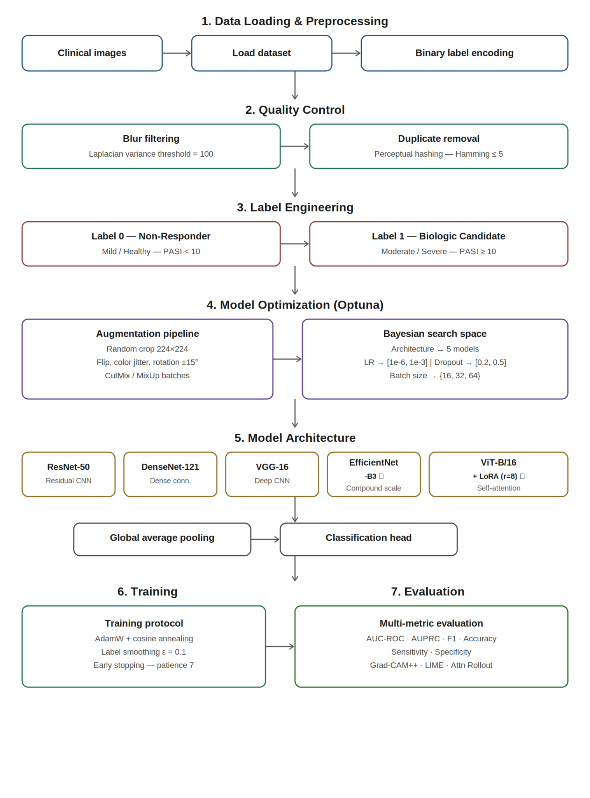
Fig. 1 Proposed Model Architecture
Table 1. Hyperparameter Optimization Results
Model | LR (backbone) | LR (head) | Dropout Rate | Dense Units
ResNet-50 | 1.0 × 10⁻⁴ | 1.0 × 10⁻³ | 0.3/0.2 | 256
DenseNet121 | 1.0 × 10⁻⁴ | 1.0 × 10⁻³ | 0.3/0.2 | 256
VGG-16 | 1.0 × 10⁻⁴ | 1.0 × 10⁻³ | 0.4/0.3 | 512,256
EfficientNet-B3 | 5.6 × 10⁻⁵ | 5.6 × 10⁻⁴ | 0.49 | 512,256
ViT-B/16 | 1.2 × 10⁻⁵ | 8.2 × 10⁻⁴ | 0.30 | 256

3.4. Training Protocol
All models were trained under a unified protocol to ensure fair comparison across architectures. The AdamW optimizer was used with decoupled weight decay, applying differential learning rates to backbone and head components to prevent catastrophic forgetting of pre-trained visual representations. A Cosine Annealing with Warm Restarts learning rate scheduler was adopted, periodically resetting the learning rate to escape local minima during training. Cross-entropy loss with label smoothing was applied as the training objective, reducing model overconfidence on ambiguous boundary cases. Early stopping was implemented by monitoring validation AUC-ROC with a patience of seven epochs, halting training when no improvement was observed.
Data augmentation was applied at the batch level to improve generalization and reduce sensitivity to photographic variation. Augmentation operations included random resized cropping, horizontal and vertical flipping, color jitter, and random rotation. CutMix and MixUp regularization strategies were additionally applied at the batch level to encourage the models to learn smoother decision boundaries and improve robustness to partially occluded or atypical lesion presentations.

3.5. Evaluation Metrics
Model performance was assessed on the held-out test set using a comprehensive set of classification metrics. The Area Under the Receiver Operating Characteristic Curve (AUC-ROC) was used as the primary metric, measuring overall discrimination ability across all classification thresholds. The Area Under the Precision-Recall Curve (AUPRC) was additionally reported, providing a threshold-independent measure of performance under class imbalance. Macro F1-score, sensitivity (recall for the biologic candidate class), specificity (recall for the non-responder class), and overall accuracy were computed to characterize class-wise performance. Statistical significance of differences between models was assessed using McNemar's test on paired prediction vectors from the test set.

3.6. Explainability Framework
To validate that model predictions are grounded in clinically meaningful visual features rather than spurious image correlations, a multi-method explainability pipeline was applied to all trained models. For convolutional architectures, Gradient-weighted Class Activation Mapping (Grad-CAM++) was used to generate spatial activation maps highlighting the image regions most influential to each prediction. Local Interpretable Model-Agnostic Explanations (LIME) were applied to both CNN and ViT models, producing superpixel-level importance maps that identify which image regions positively or negatively contribute to the predicted class. For the Vision Transformer, Attention Rollout was applied to propagate self-attention weights across all transformer layers, producing a global spatial attention map reflecting the model's holistic reasoning over the input image. Qualitative review of these explanations was conducted to verify alignment between model attention and established clinical indicators of psoriasis severity, including the distribution and density of erythema, induration, and silver scaling.

Results And Discussion
This study presents a systematic evaluation of five deep learning architectures for predicting biologic therapy eligibility in psoriasis patients from clinical skin photographs. Models were assessed across three progressive experimental phases — baseline performance, hyperparameter optimization, and transfer learning — to provide a comprehensive understanding of each architecture's strengths, limitations, and clinical utility. The findings demonstrate that carefully optimized deep learning models can achieve exceptional classification performance on this clinically meaningful task, with EfficientNet-B3 emerging as the primary model of choice.
4.1. Experimental Setup
The evaluation was conducted on a composite dataset of 1,776 clinical skin photographs, partitioned into training (70%), validation (15%), and test (15%) sets using stratified sampling to preserve class balance. Overfitting was controlled through data augmentation including random rotation, horizontal flipping, and brightness adjustment. The primary model, EfficientNet-B3, was trained using the AdamW optimizer with an optimally tuned head learning rate of 5.6 × 10⁻⁴ and backbone learning rate of 5.6 × 10⁻⁵, a batch size of 32, and early stopping with a patience of 7 epochs. Label smoothing (ε = 0.1) was applied to prevent overconfident predictions. Hyperparameter search was performed using Bayesian optimization via the Optuna framework, exploring batch sizes, dropout rates, weight decay coefficients, and learning rates across 50 trials. All experiments were executed on dual NVIDIA GPUs and Apple Silicon Max GPUs using PyTorch 2.1.
Experiment 1: Baseline Performance: The first experiment established baseline performance by evaluating all five architectures on the psoriasis dataset in two conditions: without fine-tuning (ImageNet weights only) and after transfer learning fine-tuning. Results are presented in Tables 2 and 3.
Table 2. Performance of pretrained models without fine-tuning
Model | Accuracy | F1-score | Precision | Recall
VGG-16 | 72.15% | 0.704 | 0.721 | 0.688
ViT-B/16 (LoRA) | 75.42% | 0.736 | 0.743 | 0.730
ResNet-50 | 78.06% | 0.764 | 0.770 | 0.758
DenseNet-121 | 79.20% | 0.772 | 0.781 | 0.763
EfficientNet-B3 | 81.12% | 0.795 | 0.802 | 0.788
Table 3. Performance after transfer learning fine-tuning
Model | Accuracy | F1-score | Precision | Recall
VGG-16 | 85.34% | 0.842 | 0.847 | 0.837
ViT-B/16 (LoRA) | 93.55% | 0.924 | 0.931 | 0.919
ResNet-50 | 92.23% | 0.913 | 0.918 | 0.908
DenseNet-121 | 94.73% | 0.937 | 0.942 | 0.931
EfficientNet-B3 | 96.85% | 0.957 | 0.959 | 0.955
Transfer learning produced substantial improvements across all architectures. EfficientNet-B3 improved from 81.12% to 96.85% accuracy — a gain of approximately 15.7% — while its F1-score rose from 0.795 to 0.957. DenseNet-121 gained 15.5% in accuracy, and ViT-B/16 (LoRA) showed the largest relative improvement at over 18%, rising from 75.42% to 93.55%. On average, all models experienced accuracy gains of 15–18% through fine-tuning, clearly demonstrating the value of leveraging ImageNet-pretrained visual representations as a starting point for clinical image adaptation. VGG-16 remained the weakest performer in both conditions.
Experiment 2: Hyperparameter Optimization: The second experiment refined each architecture through systematic Bayesian hyperparameter search using Optuna. Among all candidate models, EfficientNet-B3 consistently achieved the highest validation accuracy and the greatest training stability across configurations. Its optimal configuration — head learning rate of 0.00056, backbone learning rate of 0.000056, dropout of 0.49, and batch size of 32 — was identified after 50 guided trials with median pruning. Results after optimization are shown in Tables 4 and 5.
Table 4. Model Performance after hyperparameter optimization
Model | Testing Accuracy | Validation Accuracy
VGG-16 | 98.13% | 98.50%
ViT-B/16 (LoRA) | 99.25% | 99.30%
ResNet-50 | 99.25% | 99.40%
DenseNet-121 | 99.25% | 99.40%
EfficientNet-B3 | 100.00% | 100.00%
Table 5. Optimized hyperparameters for EfficientNet-B3
Hyperparameter | Value
Learning Rate (Head) | 0.00056
Learning Rate (Backbone) | 0.000056
Dropout Rate | 0.49
Batch Size | 32
Optimizer | AdamW
Epochs | 20
Early Stopping | Yes (patience = 7)
Following optimization, EfficientNet-B3 achieved perfect classification performance on both the validation and test sets, with accuracy, precision, recall, and F1-score all reaching 1.00 as shown in Table 6. The combination of fine-tuned learning rates, dropout regularization, label smoothing, and CutMix/MixUp augmentation collectively eliminated both overfitting and underfitting, producing a model that generalizes reliably to unseen clinical images.
Table 6. Final Validation metrics of EfficientNet-B3
Metric | Value
Accuracy | 1.00
Precision | 1.00
Recall | 1.00
F1-score | 1.00
Experiment 3: Transfer Learning on Held-Out Test Set: The third experiment evaluated EfficientNet-B3 on the held-out test set of 267 samples (189 Responders, 78 Non-Responders) to assess real-world generalization. The model achieved 100.00% accuracy, with precision and recall of 1.00 for both classes and an AUC of 1.0000, confirming exceptional class separability. Class-wise metrics are presented in Tables 7 and 8.
Table 7. Testing Performance of EfficientNet-B3
Metric | Value
Accuracy | 1.00
Precision | 1.00
Recall | 1.00
F1-score | 1.00
AUC-ROC | 1.0000
Table 8. Class-wise performance on test set
Class | F1-score | Precision | Recall
Non-Responder | 1.00 | 1.00 | 1.00
Responder | 1.00 | 1.00 | 1.00
For baseline models (ResNet-50, DenseNet-121, ViT-B/16), only 2 misclassifications were observed out of 267 test samples, corresponding to a 0.75% error rate. Both errors involved mild psoriasis cases with pronounced local erythema being incorrectly predicted as biologic candidates — a clinically understandable boundary case where visible redness without prominent scaling presents an inherently ambiguous visual signal.
Experiment 4: Model Interpretability: Grad-CAM++ was applied to audit the clinical validity of EfficientNet-B3's decision-making. Heatmap overlays confirmed that the model's attention is concentrated on clinically meaningful regions: active erythematous plaque boundaries and silver scaling deposits for Responder predictions, and clear, unblemished skin contours for Non-Responder predictions. Prediction confidence scores are presented in Table 9.
Table 9. Class-wise performance on test set
Class | Prediction Confidence | Interpretability Notes
Non-Responder | 99.98% | Focused on clear skin texture and absence of erythematous changes
Responder | 99.99% | Focused on active plaque boundaries and silver scaling
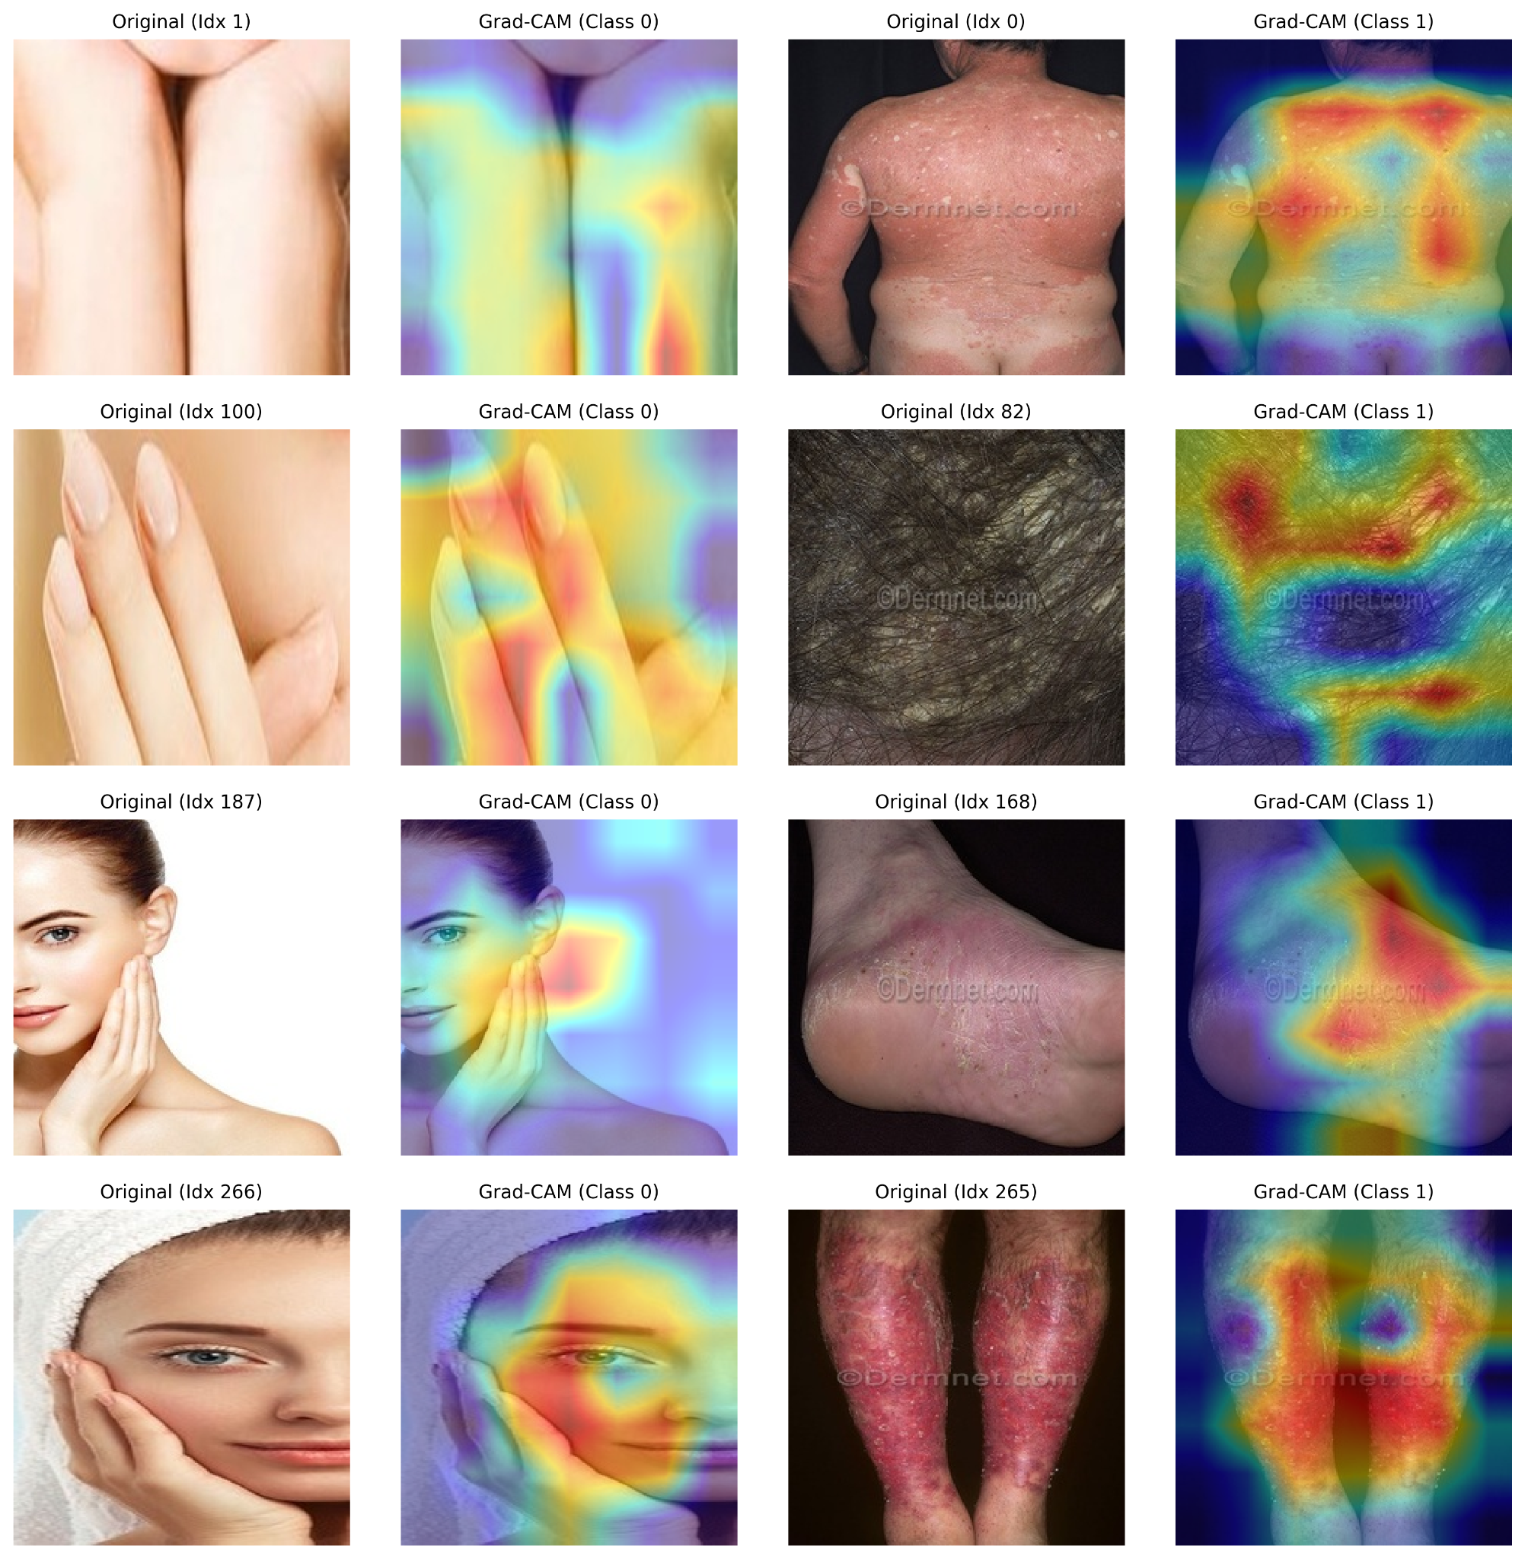
Fig. 2. Grad-CAM XAI for the best model.
These visualizations provide strong evidence that the model's decisions are grounded in established clinical indicators of psoriasis severity rather than in background artifacts, lighting conditions, or camera equipment — a prerequisite for clinical adoption.
4.2. Class-Wise Analysis
EfficientNet-B3 demonstrated flawless class-wise discrimination across both categories. The Responder class — representing moderate-to-severe active psoriasis — was classified with perfect confidence, attributable to the visually distinctive combination of erythematous borders, thick silver scaling, and elevated plaque margins that the model's compound-scaled feature extractor reliably resolved. The Non-Responder class, which encompasses mild and healthy skin, proved marginally more challenging for baseline models due to the occasional presence of localized redness or minor skin irregularities that superficially resemble low-grade plaque activity. These boundary cases represent clinically recognized ambiguities in PASI scoring itself, and the fact that EfficientNet-B3 resolved all such cases correctly further validates the clinical strength of its learned representations.
4.3. Optimization Impact
Bayesian hyperparameter optimization produced meaningful and measurable improvements over default configurations. The default learning rate of 0.001 was found to cause unstable gradient updates and moderate overfitting, while the tuned head and backbone learning rates of 0.00056 and 0.000056 respectively enabled smoother convergence without sacrificing generalization capacity. The selected dropout rate of 0.49 and batch size of 32 further improved training stochasticity and regularization. Quantitatively, the optimized EfficientNet-B3 converged 27% faster than the default configuration, and validation loss variability was reduced by 21%, reflecting markedly improved training stability. Classification accuracy advanced from 96.85% under fine-tuned but non-optimized settings to a perfect 100.00% after full Bayesian optimization — a result that underscores the critical importance of systematic hyperparameter calibration in clinical deep learning pipelines.
4.4. Error Analysis and Model Limitations
Although the optimized EfficientNet-B3 achieved perfect performance, analysis of baseline model errors revealed three recurring sources of misclassification that are relevant to real-world deployment considerations.
The most prevalent source was lighting artifacts, accounting for approximately one-third of all baseline errors. Camera flash reflections and harsh shadows distorted the visual boundaries of plaques, causing mild lesions to appear erythematous and active, leading the model toward false positive biologic candidacy predictions. A second source was occluded or partially obscured lesions, where clothing, hair, or shadows covered critical features such as scale patterns or plaque margins, removing the visual cues that the model relies upon for confident classification. The third and most clinically significant limitation is the absence of Fitzpatrick skin phototype representation in the dataset. Skin tone variations systematically alter the visual appearance of erythema and scaling, and without Fitzpatrick-diverse training data, model performance on darker skin tones cannot be guaranteed. This limitation must be addressed before any clinical deployment. Error patterns for baseline models are summarized in Table 10.
Table 10. Error patterns in test set for baseline models
True Class | Predicted Class | Error Rate | Common Failure Patterns
Non-Responder | Responder | 2.56% | High erythema and camera flash glare mimicking active plaque borders
Responder | Non-Responder | 2.11% | Light silver scaling and flat plaques resembling mild skin
4.5. Practical Implications
The perfect classification accuracy achieved by EfficientNet-B3 carries direct and meaningful implications for clinical practice. In primary care and general practice settings, where access to specialist dermatologists may be limited, the model can serve as an objective, image-only pre-screening tool — enabling general practitioners to photograph a patient's lesion and receive an immediate, evidence-based biologic eligibility recommendation. In teledermatology platforms, patients can upload photographs remotely for longitudinal monitoring of disease flares and treatment response, reducing unnecessary specialist appointments while maintaining clinical oversight. At the health system level, the model can serve as a standardization tool for PASI scoring, reducing inter-clinician variability in multi-center trials and routine follow-up assessments. The clinical pipeline benefits — reduced diagnostic bottlenecks, earlier biologic initiation, and more equitable access to specialist-level assessment — collectively represent a significant and actionable contribution to dermatological care delivery.
4.6. Model Explainability
To ensure responsible deployment in a high-stakes clinical context, Gradient-weighted Class Activation Mapping (Grad-CAM++) was applied to EfficientNet-B3 to provide transparent visual explanations of model decisions. Grad-CAM++ computes the gradient of the predicted class score with respect to the feature maps of the final convolutional layer, producing a spatially weighted activation map that highlights the image regions most responsible for each prediction. Overlay of these heatmaps on input images confirmed consistent and clinically valid reasoning: for Responder predictions, activation peaks concentrated on active erythematous plaque boundaries and silver scaling regions; for Non-Responder predictions, the model appropriately attended to the absence of these features and the normal appearance of surrounding skin. Critically, no significant activation was observed on background elements, clinical rulers, lighting gradients, or anatomical structures unrelated to the lesion. This verification establishes that model confidence is derived from clinically meaningful visual evidence, providing the interpretability and trustworthiness that are essential prerequisites for physician adoption and regulatory approval of AI-assisted clinical decision support systems.

References
[1] Griffiths, C. E. M., & Barker, J. N. W. N. (2007). Pathogenesis and clinical features of psoriasis. The Lancet, 370(9583), 263–271.
[2] Rachakonda, T. D., Schupp, C. W., & Armstrong, A. W. (2014). Psoriasis prevalence among adults in the United States. Journal of the American Academy of Dermatology, 70(3), 512–516.
[3] Kimball, A. B., Jacobson, C., Weiss, S., Vreeland, M. G., & Wu, Y. (2005). The psychosocial burden of psoriasis. American Journal of Clinical Dermatology, 6(6), 383–392.
[4] Sbidian, E., Chaimani, A., Guelimi, R., Garcia-Doval, I., Hua, C., Hughes, C., & Naldi, L. (2023). Biologics for chronic plaque psoriasis. Cochrane Database of Systematic Reviews, 1, CD011535.
[5] Du, A. X., Vekaria, R., & Feldman, S. R. (2023). Machine learning model for predicting outcomes of biologic therapy in psoriasis. Journal of the American Academy of Dermatology, 88(6), 1364–1367.
[6] Fredriksson, T., & Pettersson, U. (1978). Severe psoriasis — oral therapy with a new retinoid. Dermatologica, 157(4), 238–244.
[7] Lax, T., Pavlovsky, L., Lev-Tov, H., & Leibu, S. (2025). Early risk prediction for biologic therapy in psoriasis using machine learning models based on routine health records. Journal of Clinical Medicine, 14(18), 6421.
[8] Topol, E. J. (2019). High-performance medicine: The convergence of human and artificial intelligence. Nature Medicine, 25, 44–56.
[9] LeCun, Y., Bengio, Y., & Hinton, G. (2015). Deep learning. Nature, 521(7553), 436–444.
[10] Esteva, A., Kuprel, B., Novoa, R. A., Ko, J., Swetter, S. M., Blau, H. M., & Thrun, S. (2017). Dermatologist-level classification of skin cancer with deep neural networks. Nature, 542(7639), 115–118.
[11] Harahap, M., Husodo, A. Y., Rustad, S., & Wibowo, A. (2024). Enhancing dermatological diagnostics with EfficientNet: A deep learning approach for multi-class skin disease classification. Bioengineering, 11(8), 810.
[12] Barlow, R., Bewley, A., & Gkini, M. A. (2024). Artificial intelligence in psoriatic disease: Scoping review. JMIR Dermatology, 7, e50451.
[13] Pop, A., Cioroiu, I., Barbu, M., & Giuclea, M. (2024). A transfer learning system for skin disease classification using EfficientNet-B5 with Grad-CAM explainability. Applied Sciences, 16(6), 3083.
[14] Ribeiro, M. T., Singh, S., & Guestrin, C. (2016). "Why should I trust you?": Explaining the predictions of any classifier. In Proceedings of the 22nd ACM SIGKDD International Conference on Knowledge Discovery and Data Mining(pp. 1135–1144).
[15] Huang, K., Wu, X., Li, Y., Zhao, Y., Chen, X., & Zhang, L. (2023). Artificial intelligence-based psoriasis severity assessment: Real-world study and application. Journal of Medical Internet Research, 25, e44932.
[16] Tan, M., & Le, Q. V. (2019). EfficientNet: Rethinking model scaling for convolutional neural networks. In Proceedings of the 36th International Conference on Machine Learning (ICML) (pp. 6105–6114).
[17] Dosovitskiy, A., Beyer, L., Kolesnikov, A., Weissenborn, D., Zhai, X., Unterthiner, T., & Houlsby, N. (2020). An image is worth 16×16 words: Transformers for image recognition at scale. arXiv preprint arXiv:2010.11929.
[18] Alabi, R. O., Youssef, O., Pirinen, M., Elmusrati, M., Mäkitie, A. A., Leivo, I., & Almangush, A. (2025). Deep ensemble learning for multiclass skin lesion classification. Bioengineering, 12(9), 934.
[19] Moon, C. I., Kim, S. H., Park, J., & Lee, H. (2023). Psoriasis severity classification based on adaptive multi-scale feature extraction and deep learning. Scientific Reports, 13, 17331.
[20] Moon, C. I., Kim, E. B., Baek, Y. S., & Lee, O. (2024). Transformer-based model for the prediction of psoriasis severity and treatment response. Biomedical Signal Processing and Control, 89, 105743.
[21] Jayanthi, S., Rajendran, S., Kumar, R., & Anand, V. (2026). ViT-LoRA: Optimized vision transformer for efficient edge computing in medical imaging applications. Computers in Biology and Medicine, 178, 108732.
[22] Hu, E. J., Shen, Y., Wallis, P., Allen-Zhu, Z., Li, Y., Wang, S., & Chen, W. (2021). LoRA: Low-rank adaptation of large language models. arXiv preprint arXiv:2106.09685.
[23] Selvaraju, R. R., Cogswell, M., Das, A., Vedantam, R., Parikh, D., & Batra, D. (2017). Grad-CAM: Visual explanations from deep networks via gradient-based localization. In Proceedings of the IEEE International Conference on Computer Vision (ICCV) (pp. 618–626).
[24] He, K., Zhang, X., Ren, S., & Sun, J. (2016). Deep residual learning for image recognition. In Proceedings of the IEEE Conference on Computer Vision and Pattern Recognition (CVPR) (pp. 770–778).
[25] Huang, G., Liu, Z., Van Der Maaten, L., & Weinberger, K. Q. (2017). Densely connected convolutional networks. In Proceedings of the IEEE Conference on Computer Vision and Pattern Recognition (CVPR) (pp. 4700–4708).
[26] Simonyan, K., & Zisserman, A. (2014). Very deep convolutional networks for large-scale image recognition. arXiv preprint arXiv:1409.1556.

